**Arduino藍牙遙控車**

**App功能**

2.1 APP畫面(Designer)設計**(APP的title須包含學號與姓名)**：

2.1a App Inventor 2 Designer畫面截圖:

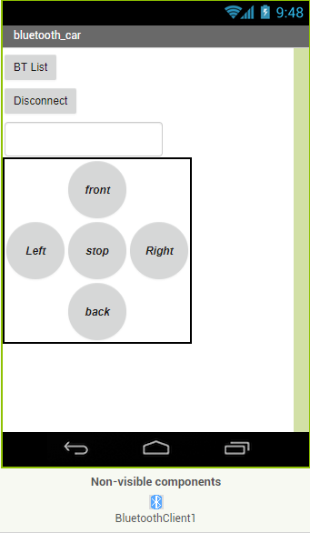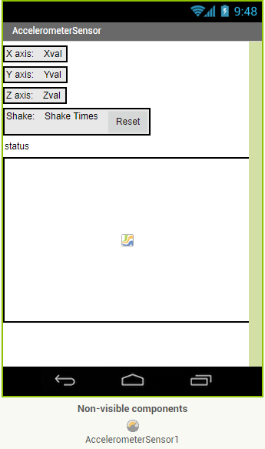

2.1b 元件清單(依照Designer畫面添加與修改) :

|  |  |  |
| --- | --- | --- |
| 類型 | 名稱 | 主要屬性 |
| ListPicker | ListPicker1 | Text: “BTList” |
| Button | Btn_Disconnect | Text: “Disconnect” |
| TextBox | TextBox1 | Text: “ ” |
| Bluetooth Client | BluetoothClient1 |  |
| TableArrangement1 | TableArrangement1 |  |
| Button | Left | Text: “ Left” |
| Button | Right | Text: “ Right” |
| Button | Front | Text: “ Front” |
| Button | Back | Text: “ back” |
| Button | Stop | Text: “ stop” |

2.2 程式(Blocks)設計：

2.a 是否使用按鈕原件元件？__Y_(Y/N)。

2.b 是否使用體感控制？__N_(Y/N)。若有，手機轉動如何對應車體移動？

說明：

2.c程式碼(BLOCK)：

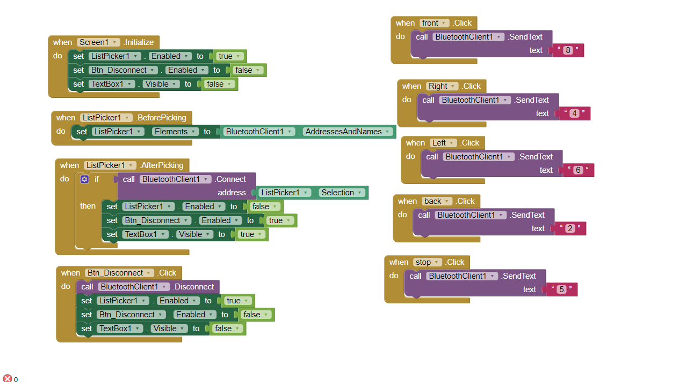

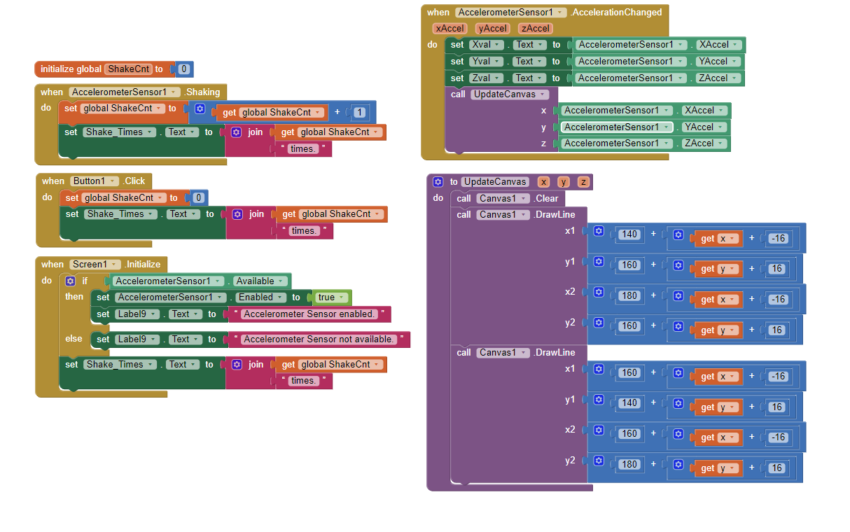

**3. Arduino 端**

3.1 Arduino車體控制對應之數位接腳

|  |  |
| --- | --- |
| **Arduino數位腳位** | Arduino控制車體 |
| D7 | 右輪方向(RM_direction) |
| D5 | 右輪轉速(RM_speed) |
| D8 | 左輪方向(LM_direction) |
| D6 | 左輪轉速(LM_speed) |
| D0 | 藍牙模組Tx |
| D1 | 藍牙模組Rx |
| D2 | 超音波模組Trig |
| D3 | 超音波模組Echo |

3.2完成車體的前進、後退、左轉、右轉功能，RM_direction與LM_direction的值分別為何(填入High/Low或 PWM值)？

|  |  |  |  |  |
| --- | --- | --- | --- | --- |
|  | 前進 | 後退 | 右轉 | 左轉 |
| RM_direction | high | Low | High | Low |
| RM_speed | Low | High | Low | Low |
| LM_direction | High | Low | Low | High |
| LM_speed | Low | High | Low | Low |

3.3 Arduino程式碼(需加註解)

#include <SoftwareSerial.h>

#include <string.h>

/*int RM_speed=5; //右輪速度

int LM_speed=6; //左輪速度

int RM_direction=7; //右輪方向

int LM_direction=8; //左輪方向*/

const int leftMotorIn1 = 5;

const int leftMotorIn2 = 6;

const int rightMotorIn3 = 7;

const int rightMotorIn4 = 8;

SoftwareSerial BT(2,3); // 接收, 傳送

const byte ledPin = 13;

char val; // 儲存接收資料的變數

String recStr; // 儲存接收資料的變數

int recStrLen;

void setup(){

Serial.begin(9600);

pinMode(ledPin, OUTPUT);

pinMode(rightMotorIn3,OUTPUT);

pinMode(leftMotorIn1,OUTPUT);

pinMode(leftMotorIn2,OUTPUT);

pinMode(rightMotorIn4,OUTPUT);

}

void loop(){

if (Serial.available() ){

val = Serial.read();

switch(val){

case '8':

forward();

break;

case '2':

backward();

break;

case '4':

left();

break;

case '6':

right();

break;

case '5':

motorstop();

break;

}

}

}

void motorstop(){//停止

digitalWrite(leftMotorIn1, LOW);

digitalWrite(leftMotorIn2, LOW);

digitalWrite(rightMotorIn3, LOW);

digitalWrite(rightMotorIn4, LOW);

}

void forward(){//前進

digitalWrite(leftMotorIn1, HIGH);

digitalWrite(leftMotorIn2, LOW);

digitalWrite(rightMotorIn3, HIGH);

digitalWrite(rightMotorIn4, LOW);

}

void backward(){//後退

digitalWrite(leftMotorIn1, LOW);

digitalWrite(leftMotorIn2, HIGH);

digitalWrite(rightMotorIn3, LOW);

digitalWrite(rightMotorIn4, HIGH);

}

void right(){//右轉

digitalWrite(leftMotorIn1, HIGH);

digitalWrite(leftMotorIn2, LOW);

digitalWrite(rightMotorIn3, LOW);

digitalWrite(rightMotorIn4, LOW);

}

void left(){//左轉

digitalWrite(leftMotorIn1, LOW);

digitalWrite(leftMotorIn2, LOW);

digitalWrite(rightMotorIn3, HIGH);

digitalWrite(rightMotorIn4, LOW);

}